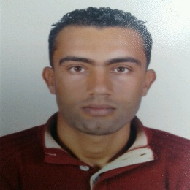Akremi

+216 28 265 515 

[Khayreddine27@gmail.com](mailto:Khayreddine27@gmail.com) →

Tamezrate Menzel Temime Nabel 8080 

27 aout 1990 

Khayreddine

Applied Degree in Sciences and Technologies of the Information and Communication



PROFESSIONAL EXPERIENCES

Internship for obtaining the Professional Master in Telecommunications and network system

 February 2015 - November 2015

 Tunisie Telecom | Tunisie

* Supervision of the telephone network.
* NGN network (architecture and performance)
* Design and developement of a network monitoring tool (JS/Servlet/HTML/CSS/JQuery/AJAX/JS).

Project for obtaining the Applied Degree in Sciences and Technologies of the Information and Communication

 January 2013 - May 2013

 Faculté des sciences de Tunis | Tunisie

* Study RFID technology.
* Design and Realization of a web application (PHP/HTML/CSS/JS/JQuery/AJAX/SQL....) for the management of national competition of researchers teachers.

DIPLOMAS AND QUALIFICATIONS

Applied Degree in Sciences and Technologies of the Information and Communication

 September/2011 - June/2013

 Faculty of sciences of Tunis | Tunisie

Got | Mention Good

Professional Master in Telecommunications and network system

 September/2014

 Faculty of sciences of Tunis | Tunisie

In progress

SKILLS

* Conception of a project (study of needs, diagrams, solution ....).
* PHP Developement.
* HTML, CSS, JS, JQuery, AJAX ...
* JAVA Developement.
* Android Developement.
* JAVA/J2ee (JSP, Servlet, JPA, HTML, CSS, JS, JQuery, AJAX) Developement.
* Matlab programming.
* C/C++ Developement.

Languages

Arabic Current

French Advanced

English Advanced